Simple thread
package simpleth;
@author ajmal
*/
public class multitr {
public class SimpleThread extends Thread {
@Override
public void run() {
System.out.println(Thread.currentThread().getId() + " is executing the thread."); }
public static void main(String[] args) {
Simpleth thread1 = new Simpleth();
Simpleth thread2 = new Simpleth();
thread1.start(); // Starts thread1
thread2.start(); // Starts thread2
}}

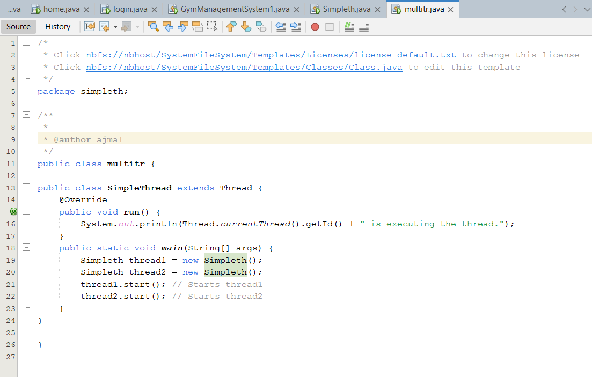

Runnable class
package multitread;

/**
*
* @author ajmal
*/
public class runnabletask implements Runnable{

@Override
public void run() {
System.out.println(Thread.currentThread().getId() + " is executingthe runnable task.");}

public static void main(String[] args) {
runnabletask task1 = new runnabletask ();
runnabletask task2 = new runnabletask ();
Thread thread1 = new Thread(task1);
Thread thread2 = new Thread(task2);
thread1.start(); // Starts thread1
thread2.start(); // Starts thread2
}
}

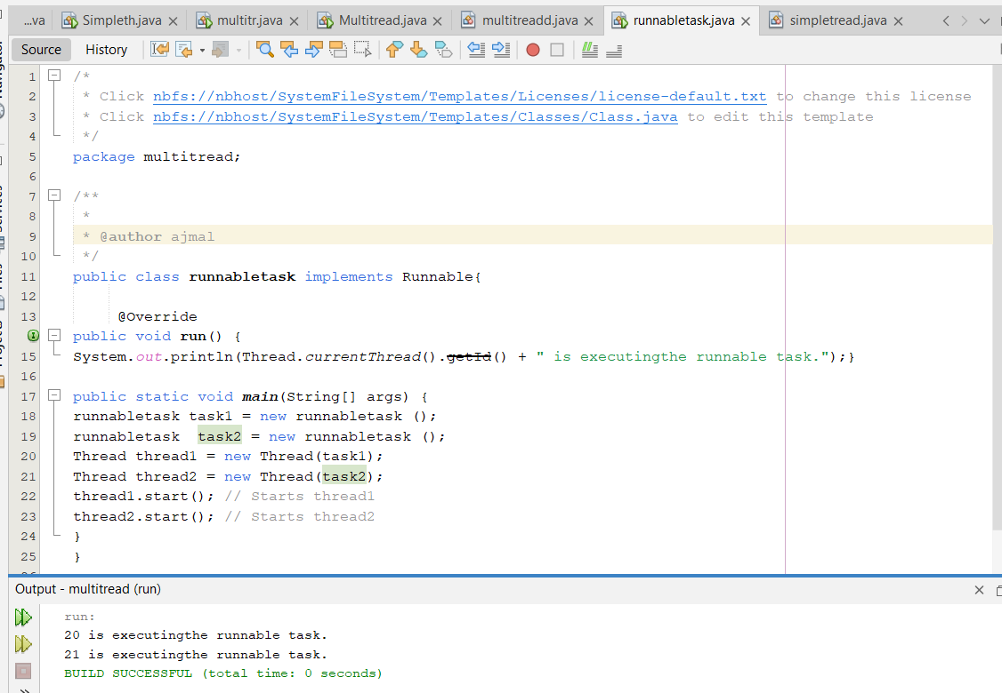

Synachronaized
ackage multitread;

import org.w3c.dom.css.Counter;

/** * @author ajmal
public class synachoranized extends thread {
private Counter counter;
public synachoranized(Counter counter) {
this.counter = counter;
}
public void run() {
for (int i = 0; i < 1000; i++) {
counter.increment();
}}
public static void main(String[] args) throws InterruptedException {
Counter counter = new Counter();
// Create and start multiple threads
synachoranized thread1 = new synachoranized(counter);
synachoranized thread2 = new synachoranizede(counter);
thread1.start();
thread2.start()
// Wait for threads to finish
thread1.join();
thread2.join();
System.out.println("Final counter value: " + counter.getCount());
}
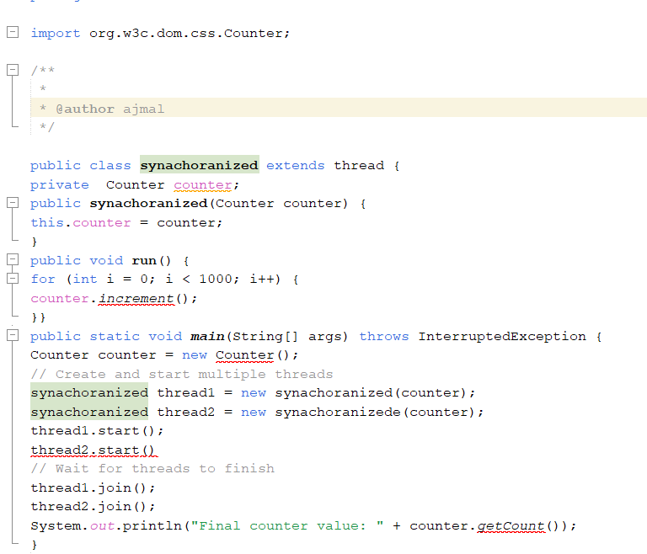

Thread poll
package tradpoll;
import java.util.concurrent.ExecutorService;
import java.util.concurrent.Executors;
ass Tradpoll {
Task class implements Runnable
static class Task implements Runnable {
private final int taskId;
public Task(int taskId) {
this.taskId = taskId; }
@Override
public void run() {
System.out.println("Task " + taskId + " is being processed by " +
Thread.currentThread().getName()); } }
public static void main(String[] args) {
// Create a thread pool with 3 threads
ExecutorService executorService = Executors.newFixedThreadPool(3);
// Submit tasks to the pool
for (int i = 1; i <= 5; i++) {
executorService.submit(new Task(i));
} Shutdown the thread poolexecutorService.shutdown(); }}
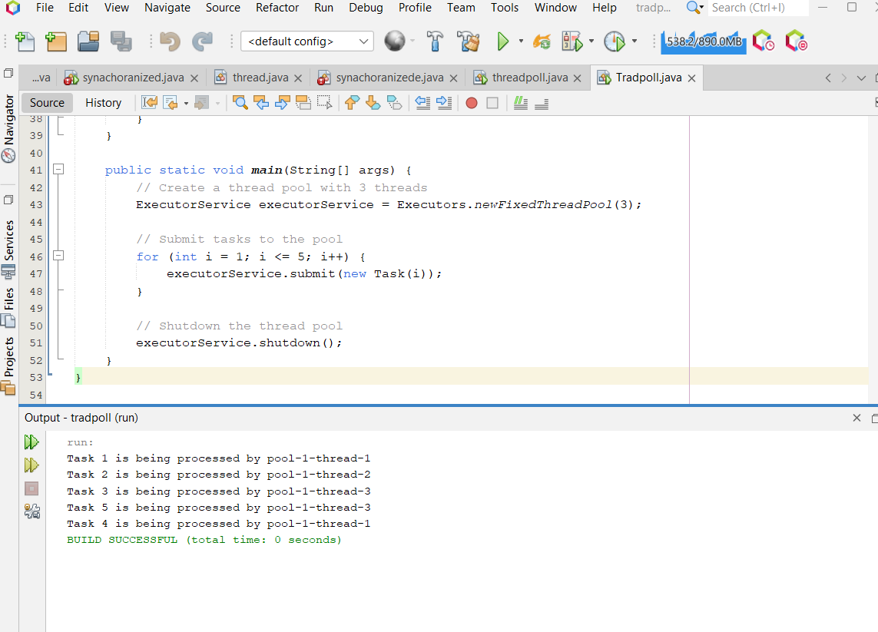

XML
package xml;

import java.io.File;
import javax.lang.model.element.Element;
import javax.xml.transform.TransformerFactory;
import javax.xml.transform.dom.DOMSource;
import javax.xml.transform.stream.StreamResult;

/**
*
* @author ajmal
*/
public class Xml {
<?xml version="1.0" encoding="UTF-8"?>
<library>
<book>
<title>The Great Gatsby</title>
<author>F. Scott Fitzgerald</author>
<year>1925</year>
<genre>Fiction</genre>
</book>
<book>
<title>To Kill a Mockingbird</title>
<author>Harper Lee</author>
<year>1960</year>
<genre>Fiction</genre>
</book>
<book>
<title>1984</title>
<author>George Orwell</author>
<year>1949</year>
<genre>Dystopian</genre>
</book>
</library>

Java XmlParser

import java.io.File; import
java.io.InputStream; import
javax.xml.parsers.*; import
javax.xml.transform.Transf
ormer; import
javax.xml.transform.Transf
ormerFactory; import
javax.xml.transform.dom.D
OMSource; import
javax.xml.transform.stream
.StreamResult; import
org.w3c.dom.*;
public class XmlParser {
public static void main(String[] args) {
try {
// Load XML from the src/xmlproject folder
InputStream inputStream = XmlParser.class.getResourceAsStream("books.xml");
if (inputStream == null) {
System.out.println("File not found in package xmlproject!");
return;
}
// Create a DocumentBuilderFactory and parse the XML content
DocumentBuilderFactory factory = DocumentBuilderFactory.newInstance();
DocumentBuilder builder = factory.newDocumentBuilder();
Document document = builder.parse(inputStream);
// Normalize document
document.getDocumentElement().normalize();
// Get all <book> elements
NodeList nodeList = document.getElementsByTagName("book");
// Loop through each book
for (int i = 0; i < nodeList.getLength(); i++) {
Node node = nodeList.item(i);
if (node.getNodeType() == Node.ELEMENT_NODE) {
Element element = (Element) node;
// Extract values for each book
String title =
element.getElementsByTagName("title").item(0).getTextContent();
String author =
element.getElementsByTagName("author").item(0).getTextContent();
String year =
element.getElementsByTagName("year").item(0).getTextContent();
String genre =
element.getElementsByTagName("genre").item(0).getTextContent();
// Print book details
System.out.println("Title: " + title);
System.out.println("Author: " + author);
System.out.println("Year: " + year);
System.out.println("Genre: " + genre);
System.out.println("--------------------");
}
}
Element firstBook = (Element) nodeList.item(0);
firstBook.getElementsByTagName("year").item(0).setTextContent("2023");
TransformerFactory transformerFactory = TransformerFactory.newInstance();
Transformer transformer = transformerFactory.newTransformer();
DOMSource source = new DOMSource(document);
StreamResult result = new StreamResult(new File("updated_books.xml"));
transformer.transform(source, result);
}
}
}
} }

Database
CREATE DATABASE employee_db;
USE employee_db;
CREATE TABLE employees (
id INT PRIMARY KEY AUTO_INCREMENT,
name VARCHAR(100),
position VARCHAR(100),
salary DECIMAL(10, 2)
);

INSERT INTO employees (name, position, salary) VALUES ('John Doe', 'Software Engineer', 75000);
INSERT INTO employees (name, position, salary) VALUES ('Jane Smith', 'HR Manager', 65000);
INSERT INTO employees (name, position, salary) VALUES ('Steve Brown', 'Team Lead', 85000);

Database connection
package jdbcexample;
import java.sql.Connection;
import java.sql.DriverManager;
import java.sql.SQLException;
public class DatabaseConnection {
private static final String URL = "jdbc:mysql://localhost:3306/employee_db"; // Database URL
private static final String USER = "root"; // Your MySQL username
private static final String PASSWORD = ""; // Your MySQL password public static Connection getConnection() throws SQLException {
public static Connection getConnection() throws SQLException {
try {
// Load the JDBC driver
Class.forName("com.mysql.cj.jdbc.Driver");
// Return the database connection
return DriverManager.getConnection(URL, USER, PASSWORD);
} catch (ClassNotFoundException | SQLException e) {
System.out.println("Connection failed: " + e.getMessage());
throw new SQLException("Failed to establish connection.");
}

